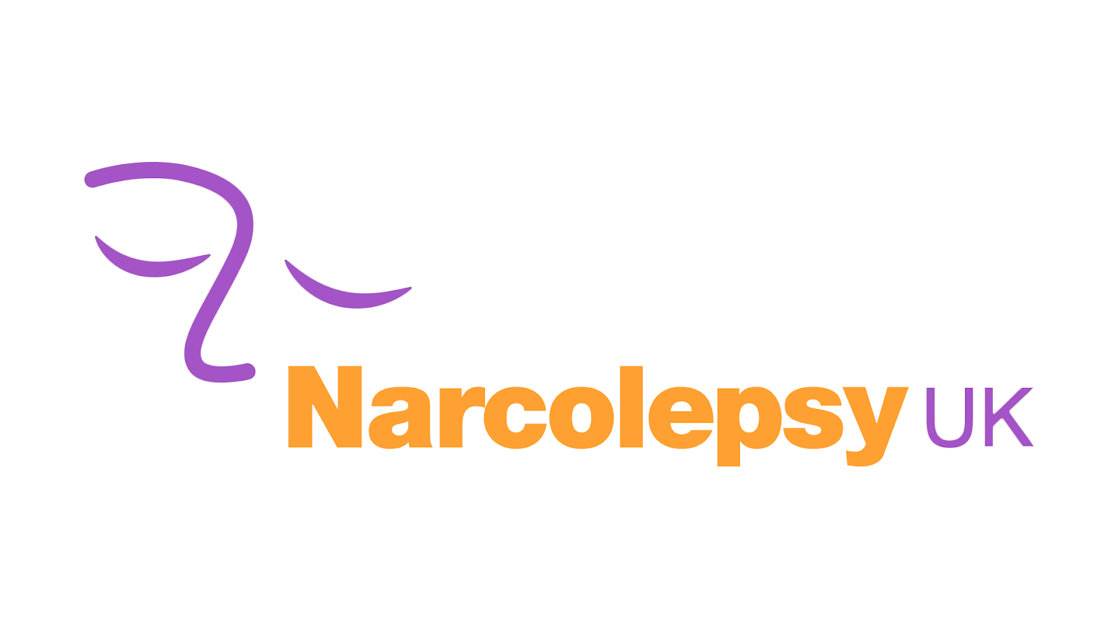
Volunteer
Handbook

Supporting people with narcolepsy, their families, carers and others interested in improving their quality of life.

PO Box 701, Huntingdon, Cambs, PE29 9LR
Narcolepsy UK is a limited company, registered in England, No 07790071
at Prentis & Co LLP, Chartered Accountants, 115c Milton Road, Cambridge CB4 1XE
Charity Registration No: 1144342. Scottish Charity No: SC043576
Tel: 0345 4500394, www.narcolepsy.org.uk

Introduction

Introduction

Narcolepsy UK aims to supporting people with narcolepsy, their families, carers and others interested in improving their quality of life. Volunteers bring a unique contribution to the work of the organisation. Your contribution helps Narcolepsy UK maintain and develop the range of services and support.

Aim and Values
Narcolepsy UK recognises that people are our most important asset. Our values are reflected clearly in the way in which we conduct ourselves and how we relate to people we support, colleagues, professionals and other members of the community who become involved with the work of the organisation.

Volunteering

What volunteers bring to Narcolepsy UK?
Volunteers undertake a range of roles which contribute to meeting the personal, financial, social and recreational needs of people we support. They are also involved in fundraising and other activities.

There is no such thing as a typical volunteer, our volunteers come from all walks of life with a whole range of different skills and experience which they bring to the organisation.

Currently our volunteers include:
- young people who want to gain new skills and experience which will help them secure college places or employment opportunities
- people who have found themselves with extra time on their hands and a wealth of experience in various areas that they can offer the organisation
- People with narcolepsy who may have used our services and want to give something back or play a larger role in the organisation.
- Family members

Narcolepsy UK values and benefits from the skills and knowledge volunteers bring to the organisation and in return we aim to ensure that volunteering with us is a positive experience. Many volunteers acquire new experiences and skills, which can lead to employment and/or training opportunities. In addition, all volunteers gain awareness of narcolepsy and of the barriers which people with narcolepsy face.

Rights & Responsibilities

Principles of Good Practice
Narcolepsy UK aims to achieve best practice in volunteering to ensure that:

- Our selection process for volunteers avoids unfair discrimination and is welcoming to all prospective volunteers.
- Our selection procedure for volunteers ensures that all volunteers are interviewed, and that appropriate references are taken up.
- We provide a clear definition of what is expected from volunteers
- We provide volunteers with the necessary skills to carry out their task through the induction and training.
- We provide structure to the volunteer role through regular contact and review
- Each Volunteer is responsible for retaining their Narcolepsy UK information in a safe and secure place where other persons in the home are not able to view private data. Just a securely closed cabinet/drawer is likely to be adequate as most information you hold can be sent over to Liam for safe storage in his Volunteers Folder within our internal system if you do not have a Narcolepsy UK storage system

Responsibilities of Narcolepsy UK
- To provide information, training and assistance to enable volunteers to meet the responsibilities of their volunteer position
- To identify a named person who will liaise with the volunteer on a regular basis for the initial 3 months of the placement and thereafter provide on-going support as often as required
- To welcome any comments from the volunteer regarding ways in which the volunteering task may be improved
- To treat the volunteer as an equal partner in achieving the aims of Narcolepsy UK

Rights of Volunteers
- To be respected and valued
- To know what their rights and responsibilities are.
- To be provided with information required to carry out their volunteering role
- To be given induction and other training appropriate to the role
- To be given support and to have a named person to oversee their volunteering duties.
- To be informed of Narcolepsy UK’s Health & Safety policy.
- To be paid reasonable out of pocket expenses.
- To be covered by Narcolepsy UK’s Insurance policy.
- To be free from discrimination

Responsibilities of Volunteers
- To carry out their agreed duties to the best of their abilities
- To adhere to the organisation's agreements and policies
- To be honest and reliable
- To respect the privacy of the service users
- To maintain matters of confidentiality
- To represent the charity well.

Diversity
Narcolepsy UK is firmly committed to diversity in all areas of its work. We believe that we have much to learn and profit from diverse cultures and perspectives, and that diversity will make our organisation more effective in meeting the needs of all our volunteers. We are committed to developing and maintaining an organisation in which differing ideas, abilities, backgrounds and needs are fostered and valued, and where those with diverse backgrounds and experiences can participate and contribute. We will regularly evaluate and monitor our progress towards diversity.

If, whilst in the process of your time with Narcolepsy UK, you feel you have witnessed or experienced discrimination, either direct or indirect – you should in the first instance speak to your Volunteer Coordinator. If you feel this is inappropriate or wish to take the matter further, then please contact the Operations Manager Narcolepsy UK.

Volunteer Recruitment

Recruitment
All volunteers will be asked to complete an application form. This provides us with basic information about you.

Once we receive your application form, we will arrange a short informal interview over the telephone.

Interview
The Volunteer Coordinator will arrange a mutually convenient telephone interview for you. Any interview with a volunteer is a two-way process, an opportunity for both parties to find out more. The interview will be informal and is merely a chat to find out more about you.

At the end of the discussion, you should be able to agree whether you want to proceed further.

Disclosure
If you are volunteering with potentially very vulnerable individuals and/or are a volunteer who will have regular contact with vulnerable people, you will have to do a disclosure.
Disclosures will be done with “Disclosure and Barring Services” if you live in England, Wales or Northern Ireland. If you live in Scotland, you will do it with “Disclosure Services”.

Please note that until your disclosure check is cleared you will not be able to go out alone with people we support. This can take up to 6 weeks.

Training & Support

Induction and training
On commencing with the organisation, you will receive a basic induction and you may be offered opportunities for training/coaching appropriate to your volunteer role.
The induction should therefore include:
- H&S issues
- Agreed plans for client contact
- Introduction to the staff, team and trustees informally to build relationships
- Agreed plan for volunteer support
- Training needs if any

During this meeting the manager will then arrange an initial start date.
Volunteer hours are collected once a month.

Support
You will be given the opportunity to liaise regularly with the volunteer coordinator to ensure you are comfortable with your volunteering role and feel supported. The volunteer coordinator will keep notes of these sessions, which you are entitled to a copy. These notes should be stored confidentially in a locked filing cabinet.

Ongoing support gives both sides the chance to give and receive feedback or air any concerns or difficulties that have been encountered.

Annual Review
You will also have the opportunity to participate in a review session, with the manager, at least annually. This will look at:
- The tasks and issues involved in the volunteering role.
- A discussion of how things are going.
- What part of the activity you feel you do particularly well.
- What part of the activity you feel least at ease with, noting reasons.
- What changes could be made to make the role easier.
- What areas you would personally like to develop.
- Future plans for self-development.
- Relationships with other volunteers, staff and management

Notes of the annual review will be held in your support file, which will be treated as confidential.

Health and safety
Narcolepsy UK has a duty of care to avoid exposing volunteers to risks to their health and safety. You must be made aware of the H&S policy and practical safety issues regarding your safety as part of the induction.

Grievance and complaints
If a volunteer has a grievance with the organisation, then you should try to resolve it locally with the help of the volunteer coordinator. Where it cannot however be resolved locally then the Operations Manager should be informed.

Resigning from a volunteer role
If a volunteer decides to resign from their role with the charity, they should try to give the charity 1 months’ notice in writing to the volunteer coordinator. This is mainly because we might need to transfer, remove or reduce access to email and electronically filed accounts and information.
However, if no notice is given then the volunteer will be locked out of any email and filed accounts with immediate effect.

Expenses & Insurance

Expenses
It is important to us that volunteers are paid all reasonable out-of-pocket expenses. These will be reimbursed including travel and meals, wherever possible the same day from the petty cash float. Expenses must be agreed in advance with the volunteer coordinator. We ask that where possible you keep all receipts for your volunteering activity.

Expenses are refunded through the relevant claim form – the volunteer coordinator will keep you informed as to how and when you should claim.

By reimbursing volunteers' expenses, we seek to ensure that volunteering is accessible to all, regardless of income.

Insurance
Volunteers are insured under our public and employer's liability cover.

Agreements & Policies

Confidentiality Agreement
WHEREAS NUK may provide to the Volunteer from time-to-time Confidential Information (including but not limited to printed matter, software or data) which is identified as being confidential and which may contain confidential intellectual property belonging to NUK (“the Confidential Information”)

In consideration of NUK supplying this Confidential Information the Volunteer hereby agrees:
- Not to use such Confidential Information for their own benefit or for the benefit of any other third party;
- Not to disclose or divulge any Confidential Information in any way to a third party other than to such NUK employees (which term shall encompass both paid staff and volunteer staff of whatsoever nature) who are directly required to utilise the information and to ensure that such employees are aware of and comply with these obligations of confidentiality;
- Not to use, copy, adapt, alter, disclose or part with possession of the Confidential Information or apply the Confidential Information for any purpose other than for the purpose for which it was provided;
- To provide proper and secure storage for such Confidential Information in tangible form whilst in their custody power or control;
- Upon the request of NUK, to destroy or procure the destruction of the Confidential Information.

- The provisions of this Agreement shall not apply to any information which is already in the public domain or is disclosed to the Volunteer by a third party who is free to divulge the information.
- This Agreement shall remain in force for a period of five years and shall continue for a further period of two years from the date of last disclosure of further Confidential Information.
- This Agreement represents the entire understanding between the two parties in the matter of Confidential Information. No waiver or amendment of any of the provisions of this Agreement shall be valid unless the waiver or amendment is made in writing and signed by the duly authorised representatives of both parties.
- The validity, construction and performance of this Agreement shall be governed by the Law of England.
- IN WITNESS where of the parties have caused this Agreement to be executed by their duly authorised on the date first above written.

Volunteer Agreement
This Volunteer Agreement describes the arrangement between Narcolepsy UK and you. We assure you of our appreciation of your volunteering with us; we will do our best to make your experience enjoyable and rewarding.

You, the Volunteer
Agree to do your best:
• To help Narcolepsy UK fulfil its aims;
• To complete all the training process;
• To read all notices, memos, emails and other communications issued by Narcolepsy UK;
• To ensure that Narcolepsy UK holds accurate records of your address, phone numbers, email address.
• To perform your volunteering role to the best of their ability;
• To follow the organisation’s procedures and standards (as in the Volunteer Handbook), in relation to its staff, volunteers and clients;
• To maintain the confidential information of the organisation and of its clients;
• To appreciate that any intellectual property rights applying to any items you produce in relation to this business will automatically become the property of Narcolepsy UK;
• To meet time commitments and standards mutually agreed, and give reasonable notice for other arrangements to be made not;
• To provide referees who may be contacted, and to agree to an Enhanced Criminal Records Bureau check being carried out should it be required

This agreement is binding in honour only, is not intended to be a legally binding contract between us and may be cancelled at any time at the discretion of either party, although we would appreciate reasonable warning should you intend to stop Volunteering and we would offer the same courtesy. Neither of us intends any employment relationship to be created either now or at any time in the future.

Personal ID Badge Policy
- I understand this badge is for use by me alone and only in relation to Narcolepsy UK Volunteer work as agreed with the Volunteer Coordinator (Liam Sloan) or Operations Manager (Nicola Rule) and I will retain emails confirming said use.
- I will ensure the badge is kept in a safe place when not in use and will report loss of the badge as soon as the loss is discovered.
- Should my name change, or should my appearance change significantly I will return the badge for amendment.
- Should I cease to volunteer for Narcolepsy UK I will return my badge forthwith.
- I will return the badge annually for updating, with a new photo, if necessary, along with Formal Photo ID (copy of passport/driving licence/etc)
- Should you experience a person making a complaint please direct them to:
Mrs Nicola Rule, Operations Manager, Narcolepsy UK
07920 650 552 nicola.rule@narcolepsy.org.uk
Or care of: PO BOX 701 HUNTINGDON Cambs PE29 9LR

